Game Design Document

Mario Game in Unity

# Game

Mario Game: Super Mario Unity – A recreation of Nintendo’s 3D Super Mario games.

Genre: Platformer, Adventure

Players: 1 Player Maximum

Game Elements

Game elements are the basic activities the player will be doing for fun

* Running
* Jumping
* Collecting Coins

# Technical Specs

Technical Form:

## Graphics:

* The game takes places in a 3D environment made of a polygonal mesh.
* 2D textures are rendered on top of the 3D objects.
* The 2D texturing includes normal mapping, which manipulates the lighting to give the illusion of 3D texturing.
* The game simulates lighting with both baked and real-time shadows and reflections.

## Physics

* Game uses the Unity physics engine.
* Many real-world physics concepts such as Gravity, Laws of Motion, and friction.

Development

## Engine

* The game will be developed in the Unity Game Engine.
* All models and resources will be borrowed from Nintendo’s Mario Games.

## Platform

* The Game will be exclusive to PC and Mac. It can be played with either a controller (could be PlayStation, Xbox, Nintendo, etc) or a Keyboard.

## Language

* The game (as Unity requires) will be written exclusively in C#. However, Unity uses it’s own scripting language ‘ShaderLab’ for its lighting system, but this is not used by the developers.

## Gameplay

* The first image represents potential gameplay mechanics. The second represents a potential UI for the game. Not every element will be present in the game—It all

depends on time constrains and what gets added in. 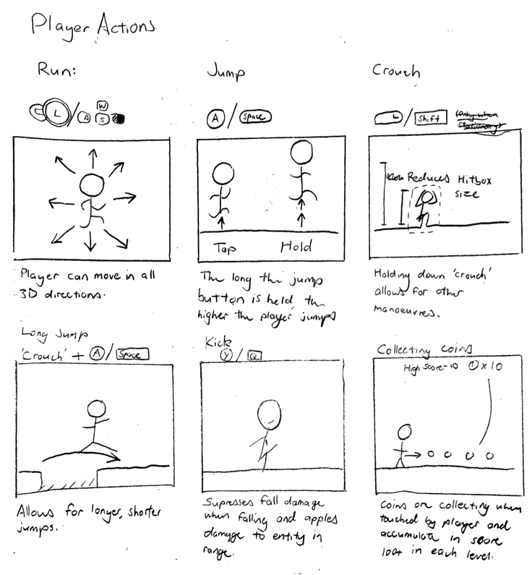

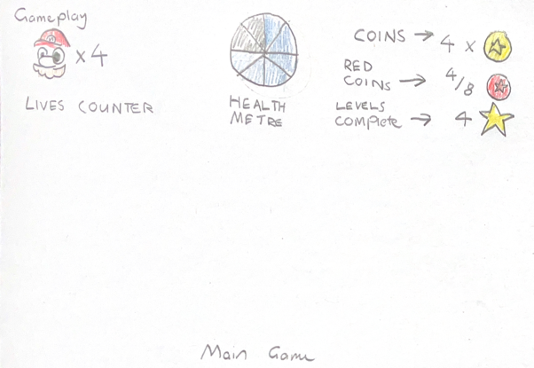

## Potential Mechanics

### Main Features

* Running and Jumping in a 3D environment
* Long jumping
* Signposts (In game hints)
* A title screen and menu, including a settings option.
* Coins/Collectables.
* Both Controller and Keyboard support.
* Music

### Optional - Extra Features

A pause menu.

Intro cutscenes.

Save/Load feature.

High score tracking. (Per individual level)

Completion reward.

Wall-Jumping

More levels

Enemies

Health System

## Source Material

pasted-image.tiff

Pictured above, Super Mario 64 was the first 3D Super Mario game by Nintendo. It’s well known for its innovative 3D platforming mechanics, which although don’t hold up well, were groundbreaking back in 1996.

I have chosen to recreate many of the mechanics of the game. I have a lot of passion for this game and would like to develop a challenging, although achievable, game for my assignment.